1. *Azure DevOps Process*

Please ensure to go through the below link for the different process available in Azure DevOps

<https://docs.microsoft.com/en-us/azure/devops/boards/get-started/what-is-azure-boards?view=azure-devops&tabs=agile-process>

Posting the different process diagrams from the above link

**Agile Process**

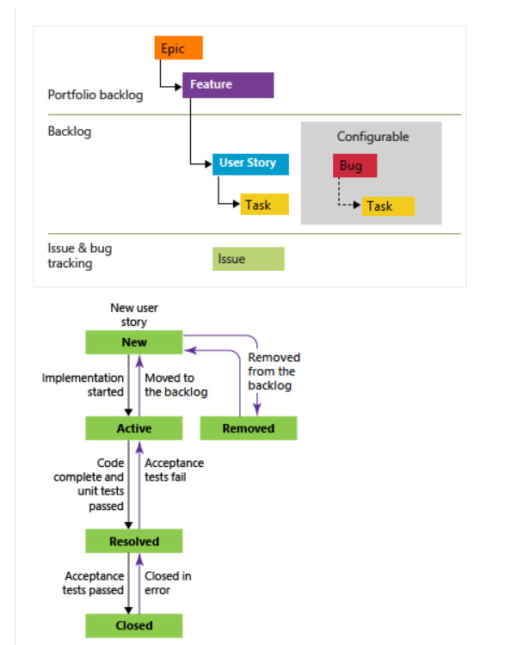

**Basic Process**

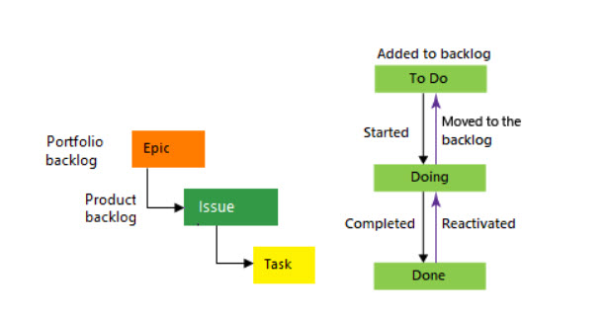

**Scrum process**

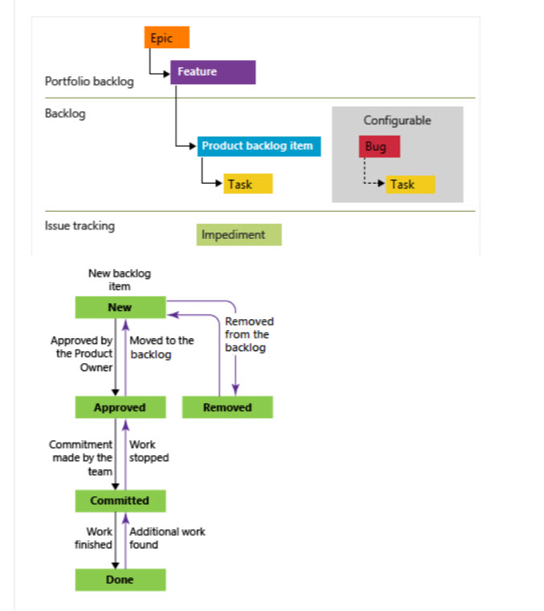

**CMMI**

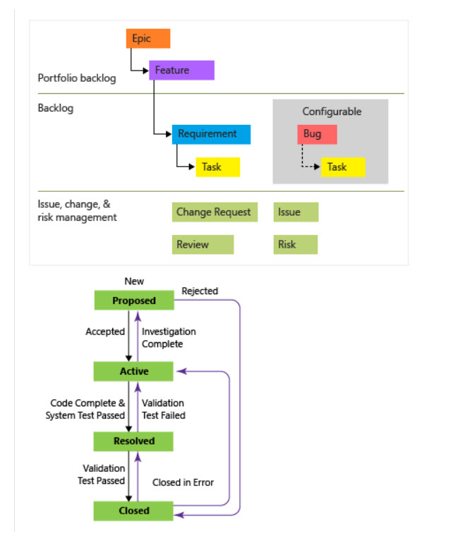

1. *Different charts in Azure DevOps Boards*

Giving the reference for the different charts

<https://docs.microsoft.com/en-us/azure/devops/report/dashboards/overview?view=azure-devops>

